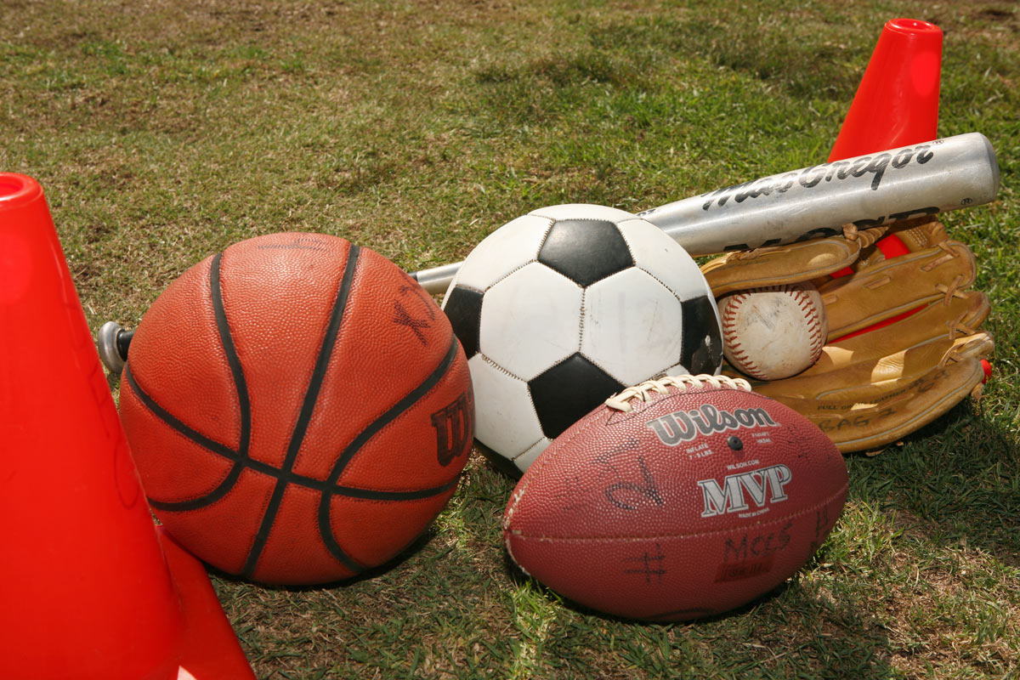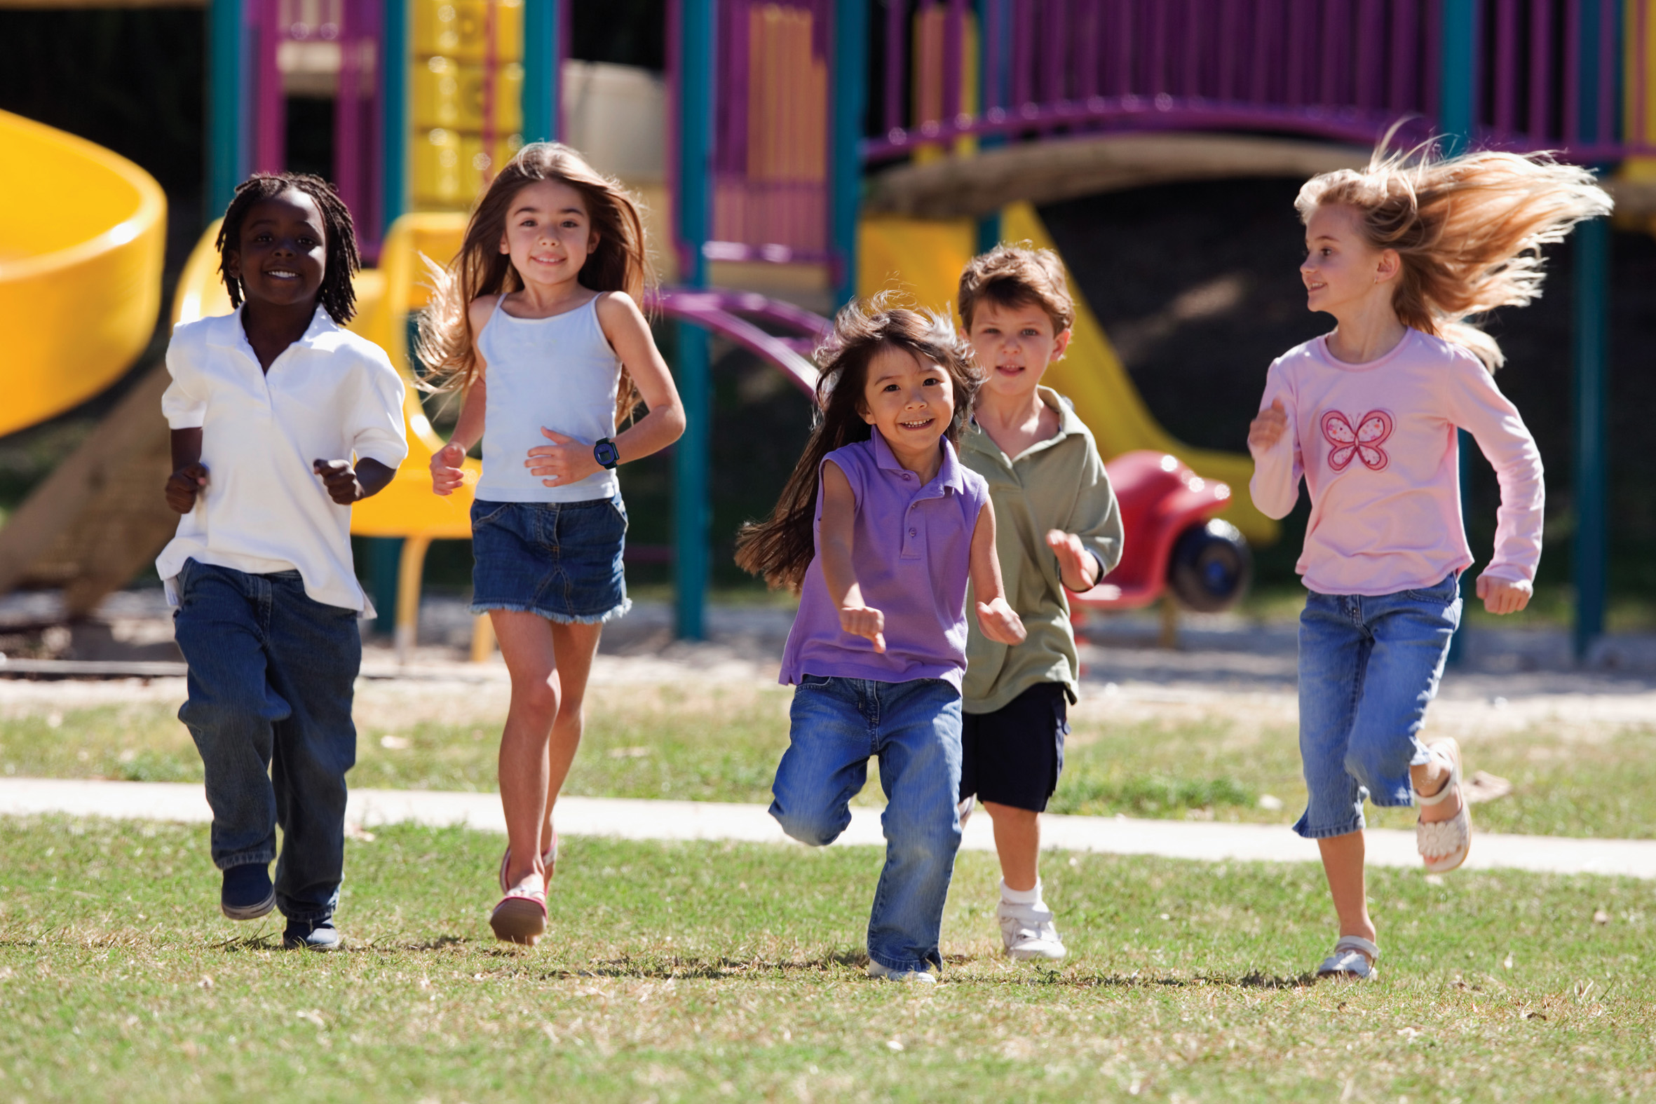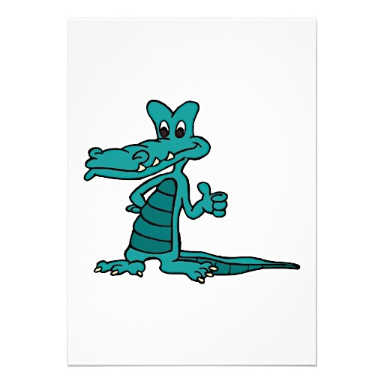

927 Miccosukee Road  
Tallahassee, FL.32308

[www.sullivan.leon.k12.fl.us](http://www.sullivan.leon.k12.fl.us)

**P.E. TEACHERS**

**Coach Banks** [banksj@leonschools.net](mailto:banksj@leonschools.net)

**Coach Shovlain** [shovlainp@leonschools.net](mailto:shovlainp@leonschools.net)

Kate Sullivan Elementary

🙞 🙜

4 – Indicates excellent effort/participation of benchmark.

3 - Indicates consistent effort/participation of benchmark.

2 - Indicates inconsistent effort/participation of benchmark.

1 – Indicates minimal effort/participation in the domain or strand combination

Kate Sullivan Physical Education

# Grading Policy

🙞 🙜

The Pupil Progress Report states that students will be graded based on their acquisition of certain percentage of the skills, concepts and processes as outlined by the Grade Level Benchmarks taught during the nine weeks. Kindergarten and First grade P.E. grades are based on achievement of skills, concepts and performance outcomes. Second through fifth grade P.E. grades are weighted equally on skill mastery, knowledge of concepts (written & oral), and performance outcomes. The number of assessments will vary since P.E teachers may only serve students 12 times during a 9 weeks. All students will receive a letter grade.

**GRADING SCALE**

**K & 1** **3-5**

A A = 90-100

B B = 80-89

C C = 70-79

N D = 60-69

F = 0-59

#### Physical Education Grading Policy

## Effort & Participation Rubric (K-5)

Physically Educating Crocodiles

**P.E. Curriculum**

**A Physically Educated Crocodile**

**Expectations & Class Rules**

**Required Attire For P.E.**

Students will be **Respectful, Responsible,** and **Safe** at all times by:

1. Demonstrating attending behavior.
2. Following directions the first time.
3. Doing quality work at all times.
4. Taking care of equipment.
5. Demonstrating Sportsmanship.
6. Keeping hands, feet and all other objects to themselves.
7. Accept responsibility for their actions.



* Class expectations, rules, safety and procedures
* Locomotor movements (K-1), Fitness Tests (2-5)
* Volleying & Dribbling
* Striking with rackets and paddles
* Kicking and Punting
* Throwing and Catching
* Striking with long handled implements
* Field Day Games
* Educational Dance and Gymnastics
* Integration of math, science and language arts.

Has learned skills necessary to perform a variety of physical activities.

1. Is physically fit.
2. Participates regularly in physical activity.
3. Knows the implications of and benefits from involvement in physical activities.
4. Values physical activity and its contributions to a healthful lifestyle.

Closed toe shoes, preferably tennis shoes are the only footwear allowed in physical education. CROCS, sandals and any open toe or heel shoe are unsafe for physical activity. Shoes with heels ½ inch or greater have a high potential for injury and are not allowed. Additionally, females wearing skirts and/or dresses should bring a pair of shorts to be worn underneath during physical activity. Students wearing inappropriate attire will be required to sit out of activity during class. If the student cannot participate, he/she cannot earn effort/participation points and will lose quality practice time. Therefore, **wearing inappropriate attire will negatively affect his/her grade in physical education.**

**3rd – 5th GRADES**

*AEROBIC CAPACITY*

1) **PACER** (Progressive Aerobic Cardiovascular Endurance Run) – Set to music, a paced, 20-meter shuttle run increasing in intensity as time progresses or **One-Mile Run** – Students run (or walk if needed) one mile as fast as they can.

*MUSCULAR STRENGTH AND ENDURANCE*

2) **Curl Up** – Measuring abdominal strength and endurance, students lie down with knees bent and feet unanchored. Set to a specified pace, students complete as many repetitions as possible to a maximum of 75.

3) **Trunk Lift** – Measuring trunk extensor strength, students lie face down and slowly raise their upper body long enough for the tester to measure the distance between the floor and the student’s chin.

4) **Push-Up** – Measuring upper body strength and endurance, students lower body to a 90-degree elbow angle and push up. Set to a specified pace, students complete as many repetitions as possible.

*FLEXIBILITY*

5) **Back-Saver Sit and Reach** – Testing one leg at a time, students sit with one knee bent and one leg straight against a box and reach forward

For more information check out <http://www.fitnessgram.net/home/>